**VAISHALI BOKADIYA**

**CODING ASSESSMENT**

**QUESTION 2**

**Q2. Execute all the join with examples.**

Joins in SQL are used to join the tables using a particular column.

There are the following types of joins:

* EQUI JOIN
* NON EQUI JOIN
* SELF JOIN
* CROSS JOIN
* INNER JOIN
* LEFT JOIN
* RIGHT JOIN
* FULL OUTER JOIN

Let’s discuss each with example:

* **EQUI JOIN**

EQUI JOIN in SQL is used to join tables using equality ie. in the ON clause it checks for the equality.

Example:

SELECT * FROM animals

JOIN shelters ON animals.shelter=shelters.id;

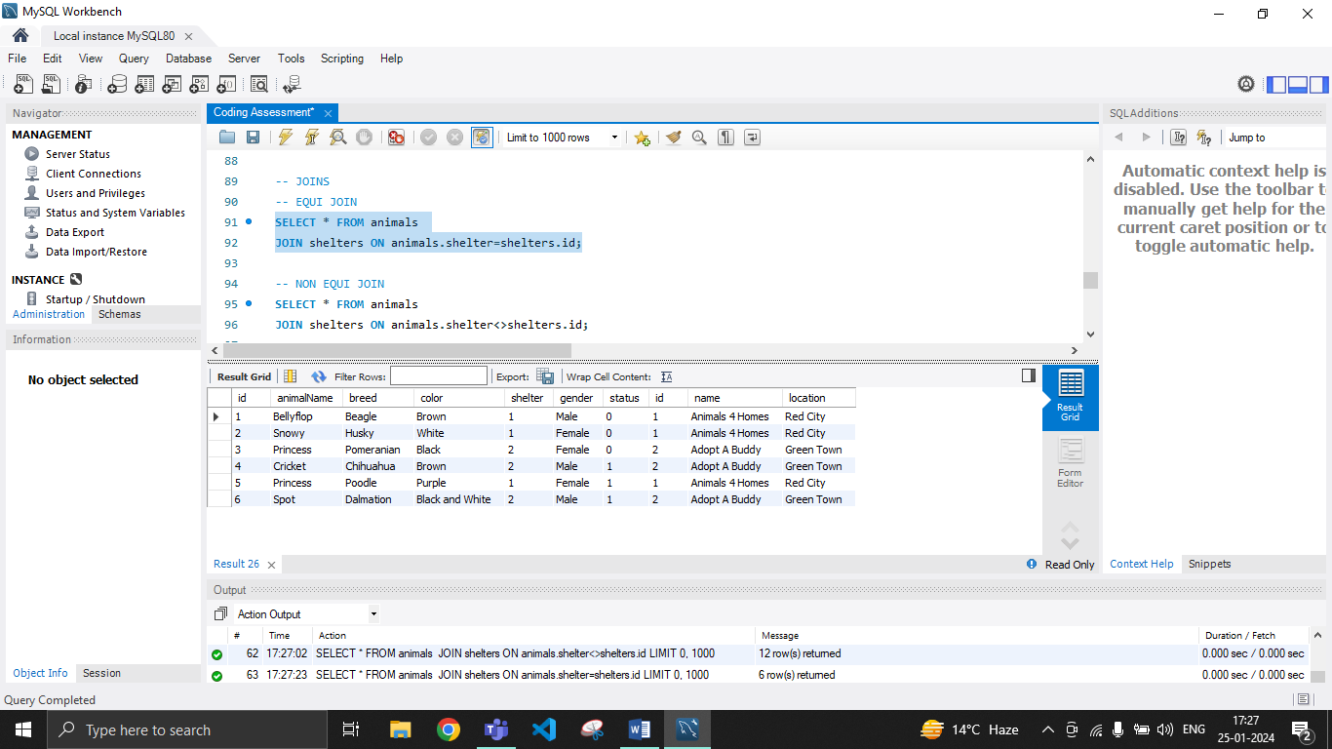

* **NON EQUI JOIN**

NON EQUI JOIN in SQL is used to join tables using any other operator than equal ie. in the ON clause it has a comparison operator rather than equal.

Example:

SELECT * FROM animals

JOIN shelters ON animals.shelter<>shelters.id;

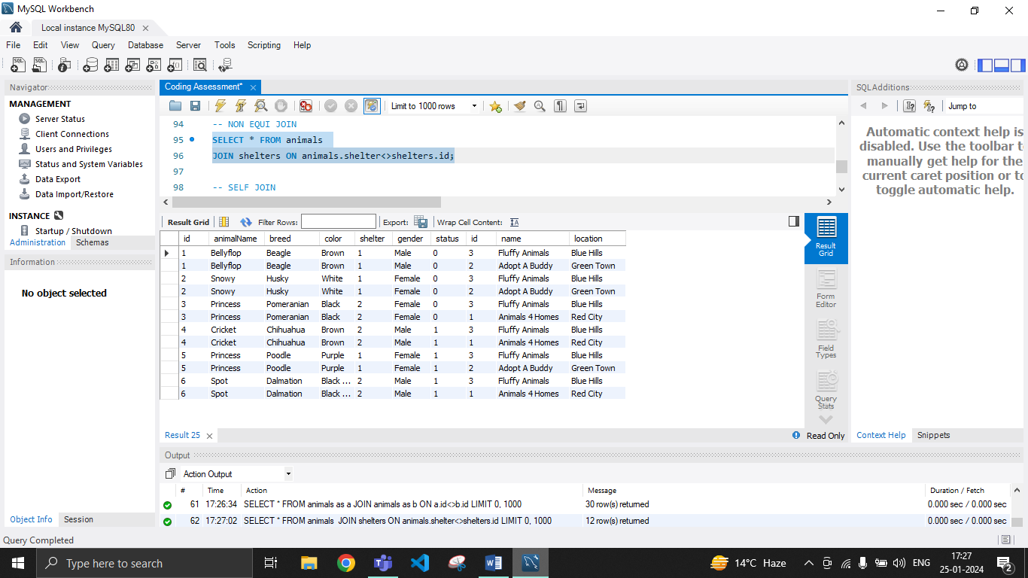

* **SELF JOIN**

SELF JOIN in SQL is used to join a table with itself.

Example:

SELECT * FROM animals as a

JOIN animals as b ON a.id<>b.id;

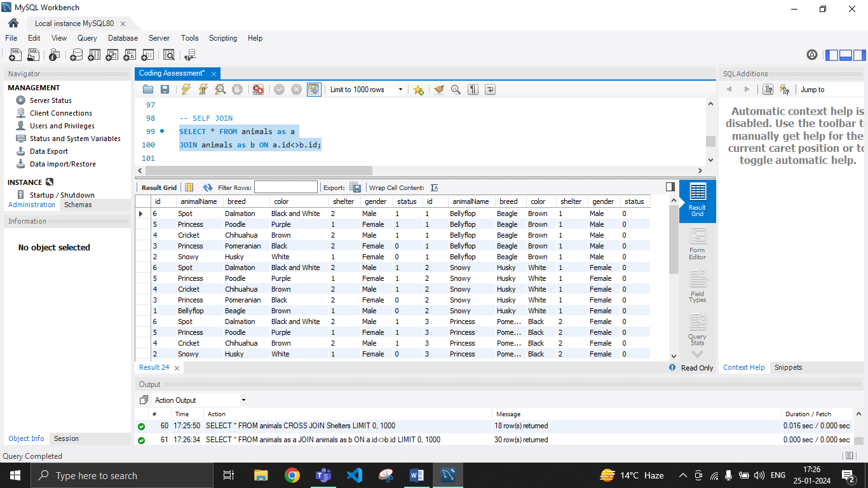

* **CROSS JOIN**

CROSS JOIN in SQL is used to match every column of the first table with every column of the second table. The result set of this join is very large in size.

Example:

SELECT * FROM animals

CROSS JOIN Shelters;

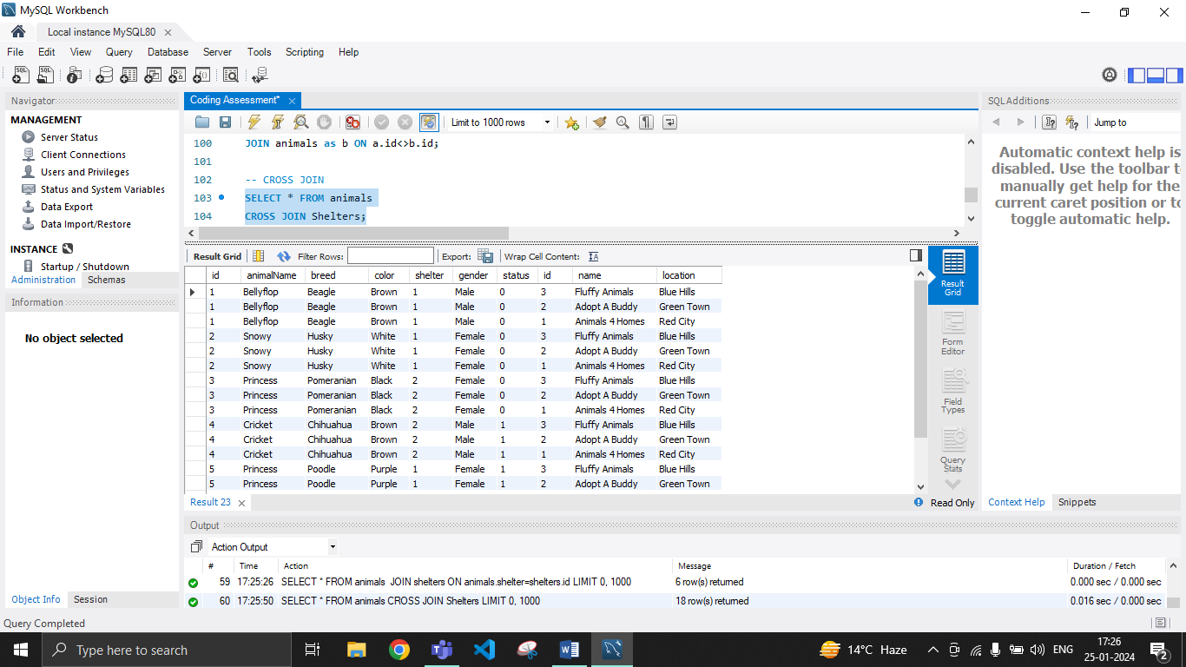

* **INNER JOIN**

INNER JOIN in SQL is a type of join which returns only the matching values from both the tables.

Example:

SELECT * FROM animals

JOIN shelters ON animals.shelter=shelters.id;

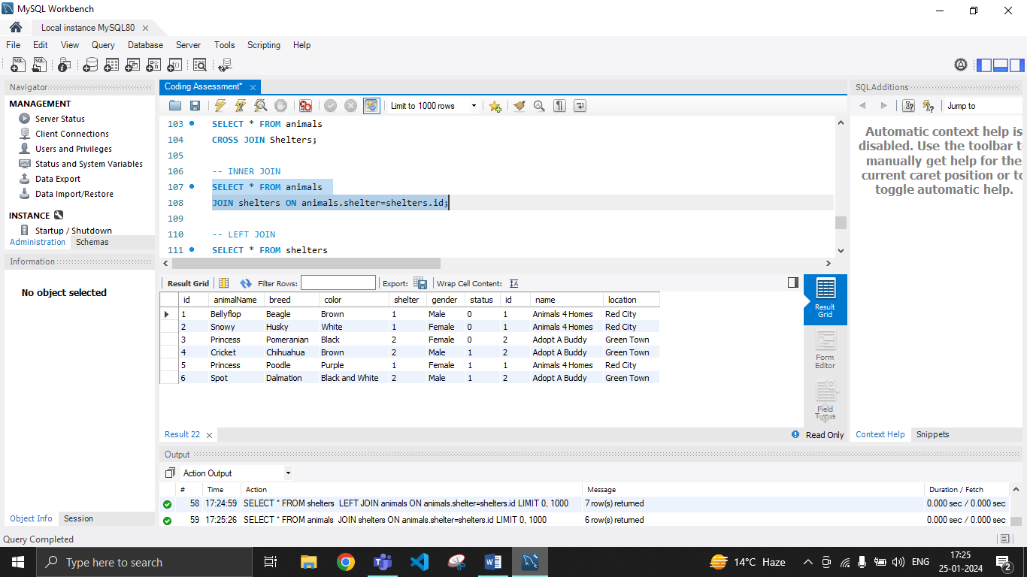

* **LEFT JOIN**

LEFT JOIN in SQL is a type of join which returns all the matching values of the both tables and also the non matching values from the left table.

Example:

SELECT * FROM shelters

LEFT JOIN animals ON animals.shelter=shelters.id;

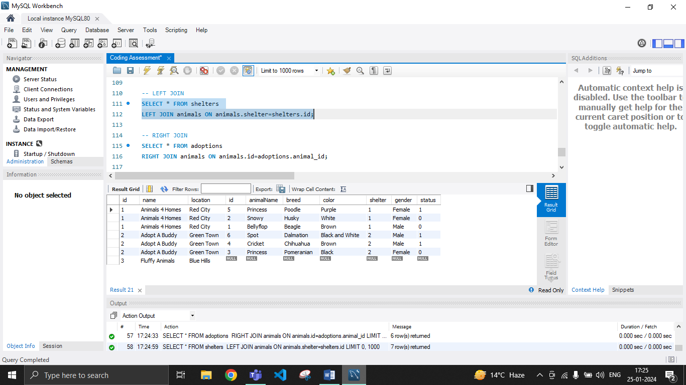

* **RIGHT JOIN**

RIGHT JOIN in SQL is a type of join which returns all the matching values of the both tables and also the non matching values from the right table.

Example:

SELECT * FROM adoptions

RIGHT JOIN animals ON animals.id=adoptions.animal_id;

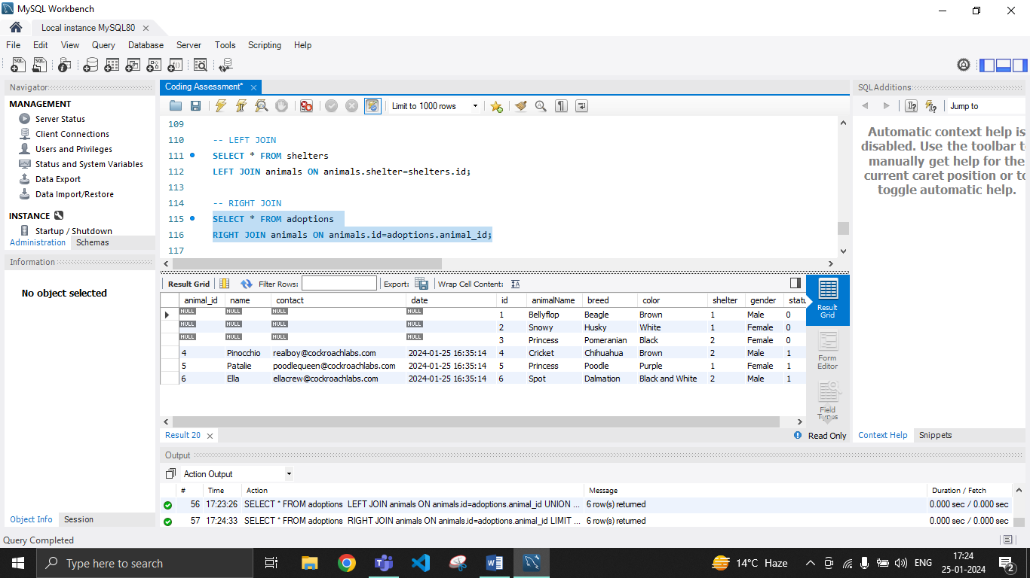

* **FULL OUTER JOIN**

FULL OUTER JOIN in SQL is a type of join which returns all the matching and non matching values of the both tables.

Example:

SELECT * FROM adoptions

LEFT JOIN animals ON animals.id=adoptions.animal_id

UNION

SELECT * FROM adoptions

